M7.14 Factors Testing

Optional Form Factors

SID = 105639

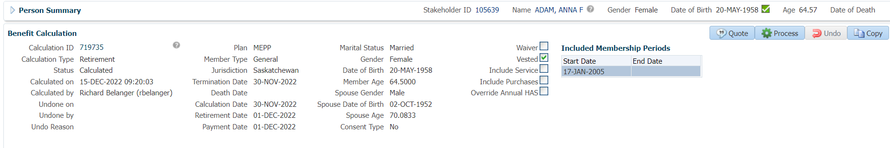

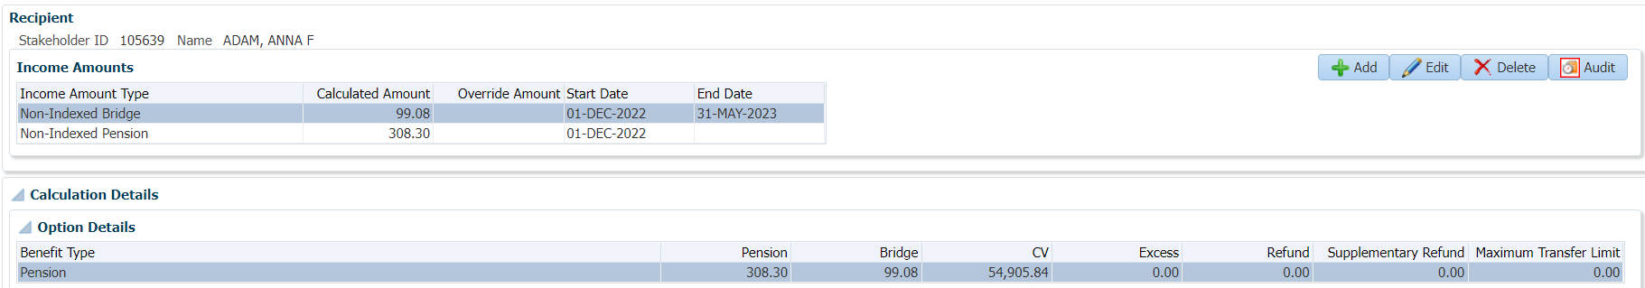

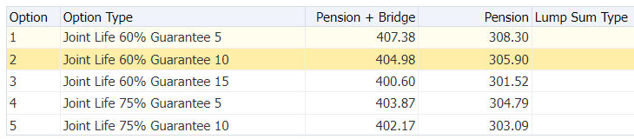

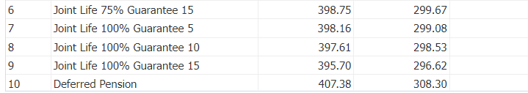

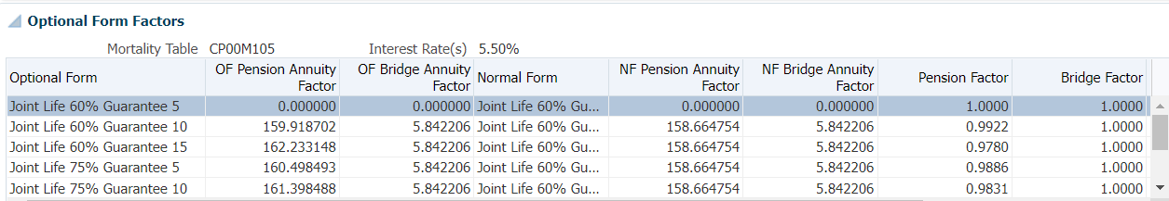



**Joint Life 60% Guarantee 5; 308.30 x 1.0000 = 308.30; Bridge = 99.08; 407.38**

Joint Life 60% Guarantee 10; 308.30 x 0.9922 = 305.90; Bridge = 99.08; 404.98

**Joint Life 60% Guarantee 15; 308.30 x 0.9780 = 301.52; Bridge = 99.08; 400.60**

Joint Life 75% Guarantee 5; 308.30 x 0.9886 = 304.79; Bridge = 99.08; 403.87

**Joint Life 75% Guarantee 10; 308.30 x 0.9831 = 303.09;** **Bridge = 99.08; 402.17**

Joint Life 60% Guarantee 15; 308.30 x 0.9720 = 299.67; Bridge = 99.08; 398.75

**Joint Life 100% Guarantee 5; 308.30 x 0.9701 = 299.08; Bridge = 99.08; 398.16**

Joint Life 100% Guarantee 10; 308.30 x 0.9683 = 298.53; Bridge = 99.08; 397.61

**Joint Life 100% Guarantee 15; 308.30 x 0.9621 = 296.62; Bridge = 99.08; 395.70**

SID = 100586

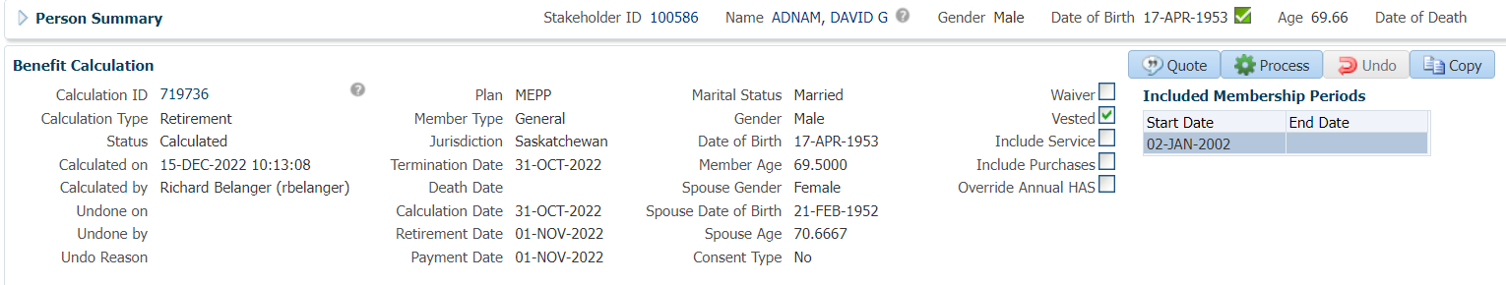

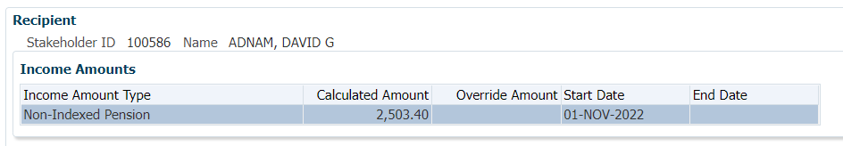

Member is 69, no Bridge included

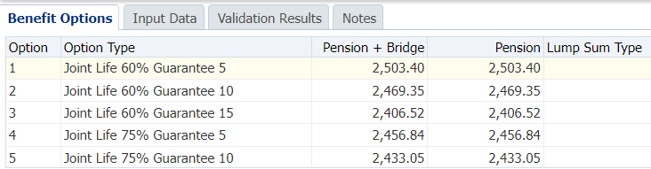

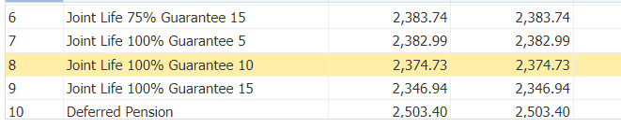

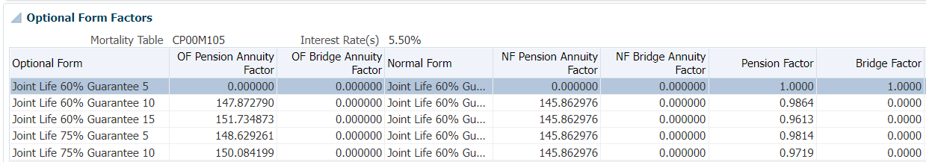



**Joint Life 60% Guarantee 5; 2503.40 x 1.0000 = 2503.40**

Joint Life 60% Guarantee 10; 2503.40 x 0.9864 = 2,469.35

**Joint Life 60% Guarantee 15; 2503.40 x 0.9613 = 2,406.52**

Joint Life 75% Guarantee 5; 2503.40 x 0.9814 = 2,456.84

**Joint Life 75% Guarantee 10; 2503.40 x 0.9719 = 2,433.05**

Joint Life 75% Guarantee 15; 2503.40 x 0.9522 = 2,383.73

**Joint Life 100% Guarantee 5; 2503.40 x 0.9519 = 2,382.99**

Joint Life 100% Guarantee 10; 2503.40 x 0.9486 = 2,374.73

**Joint Life 100% Guarantee 15; 2503.40 x 0.9375 = 2,346.94**

SID = 105121



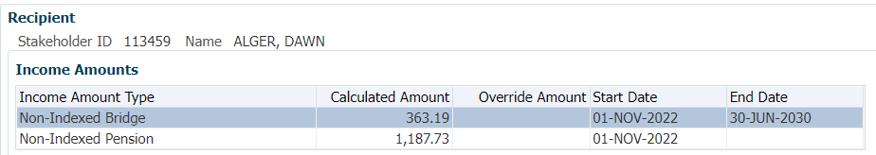

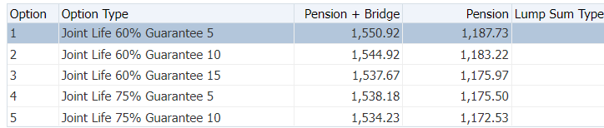

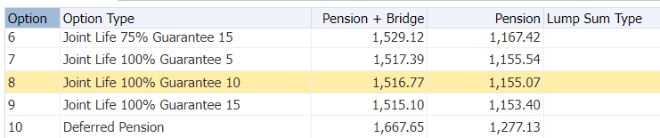

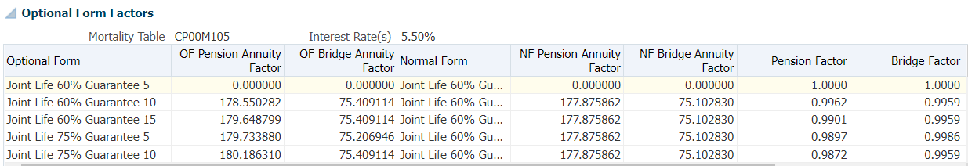



**Joint Life 60% Guarantee 5; 1187.73 x 1.0000 = 1187.73; Bridge = 363.19 x 1.0000 = 363.19; 1,550.92**

Joint Life 60% Guarantee 10; 1187.73 x 0.9962 = 1,183.22; Bridge = 363.19 x 0.9959 = 361.70; 1,544.92

**Joint Life 60% Guarantee 15; 1187.73 x 0.9901 = 1,175.97; Bridge = 363.19 x 0.9959 = 361.70; 1,537.67**

Joint Life 75% Guarantee 5; 1187.73 x 0.9897 = 1,175.50; Bridge = 363.19 x 0.9986 = 362.68; 1,538.18

**Joint Life 75% Guarantee 10; 1187.73 x 0.9872 = 1,172.53; Bridge = 363.19 x 0.9959 = 361.70; 1,534.23**

Joint Life 75% Guarantee 15; 1187.73 x 0.9829 = 1,167.42; Bridge = 363.19 x 0.9959 = 361.70; 1,529.12

**Joint Life 100% Guarantee 5; 1187.73 x 0.9729 = 1,155.54; Bridge = 363.19 x 0.9963 = 361.85; 1,517.39**

Joint Life 100% Guarantee 10; 1187.73 x 0.9725 = 1,155.07; Bridge = 363.19 x 0.9959 = 361.70; 1,516.77

**Joint Life 100% Guarantee 15; 1187.73 x 0.9711 = 1,153.40; Bridge = 363.19 x 0.9959 = 361.70; 1,515.10**

Commuted Value Factor Testing

SID = 124610

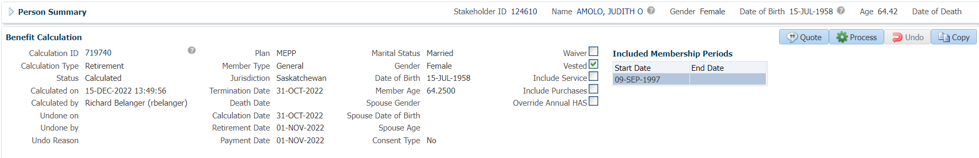

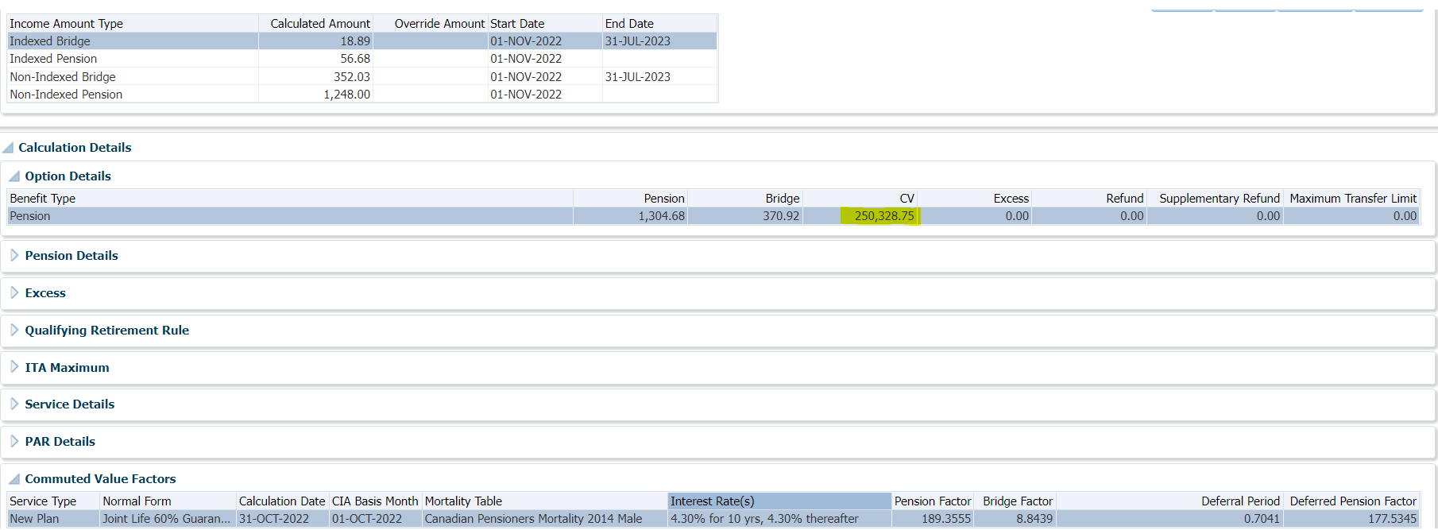

Pension = 56.68 + 1248.00 = 1,304.68; Bridge = 18.89 + 352.03 = 370.92

1304.68 x 189.3555 = 247,048.33

370.92 x 8.8439 = 3,280.38

247,048.33 + 3280.38 = 250,328.71

SID = 114790

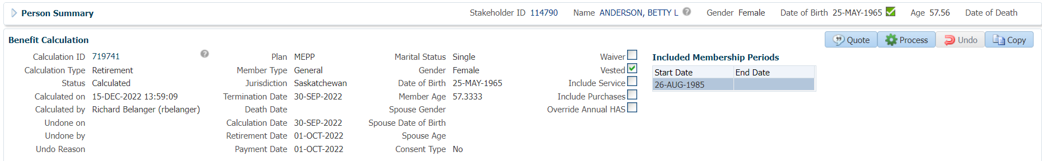

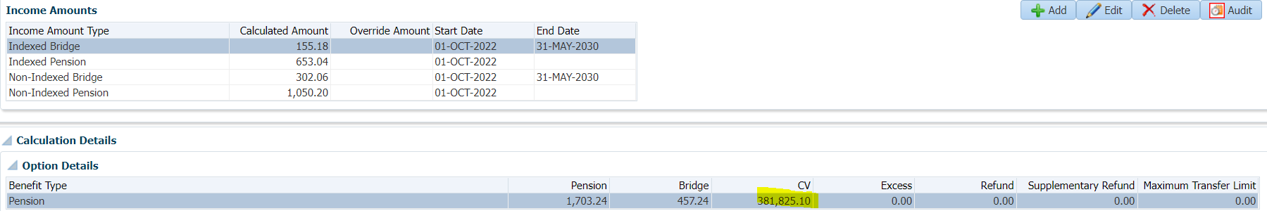



Pension = 653.04 + 1050.20 = 1,703.24; Bridge = 155.18 + 302.06 = 457.24

1,703.24 x 203.1046 = 345,935.88

457.24 x 78.4909 = 35,889.18

345,935.88 + 35,889.18 = 381,825.06

SID = 106133

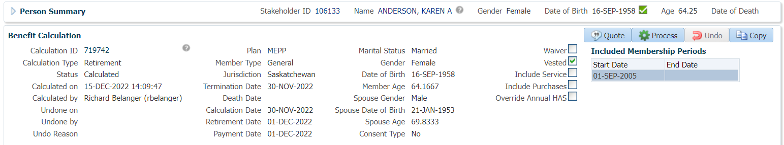

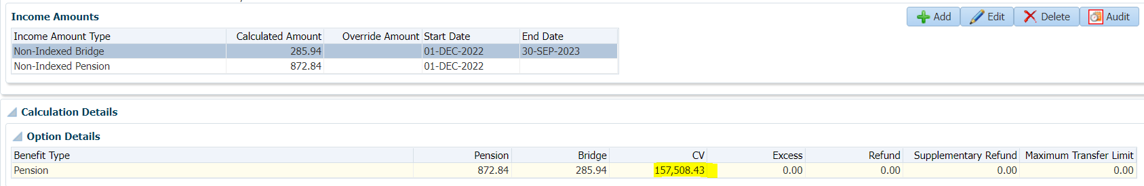



Pension = 872.84; Bridge = 285.94

872.84 x 177.2444 = 154,706.00

285.94 x 9.8008 = 2,802.44

150,341.80 + 2,802.44= 157,508.44